Experimental Load Group

This experiment tests participants’ ability to make associative judgments when they are given no extra things to do and extra things to do. There are two versions of this experiment that you will run. Both of these are label EXP for experimental.

1. Check if participants are coming (use the how to SONA guide).
2. Before participants arrive set up computer:
   1. Go to the “load experiment” folder on the desktop.
   2. Use the experiment numbers guide on the corkboard.
   3. Be sure to only run ONE type of group (of the four) per session. If you mix and match the participants will end at different times and it makes them act weird.
3. Start the experiment:
   1. Go back to the load experiment folder.
   2. Select the right experimental group (load or no load).
   3. 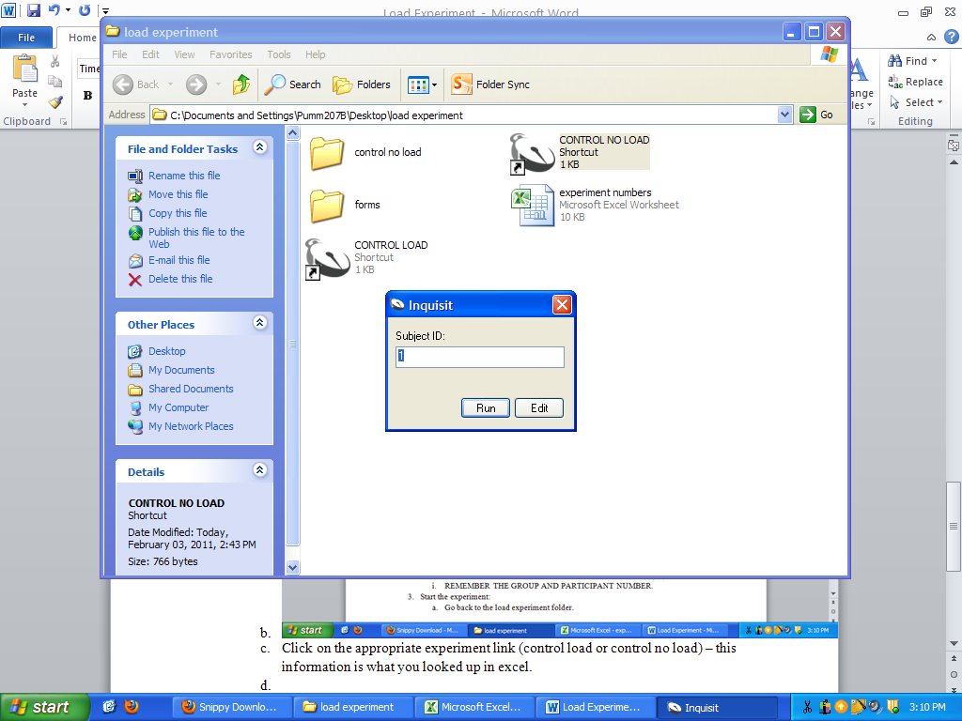
   4. This subject ID: box will appear. Type in the participant number and press run.
   5. If it is working, you will see this screen:
   6. 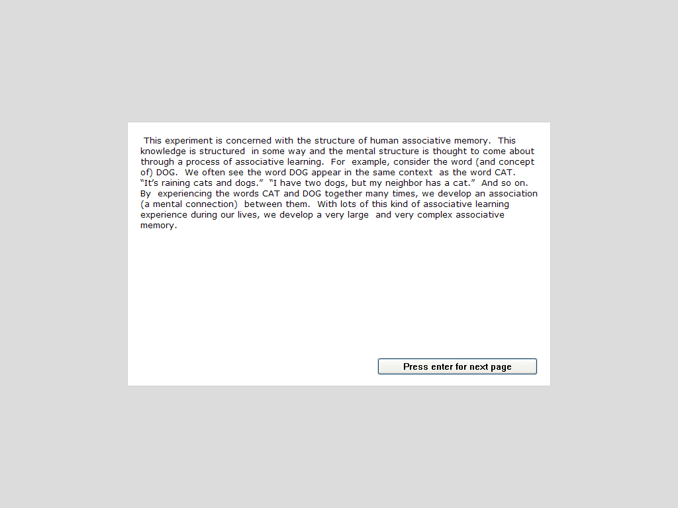
4. When the participant arrives:
   1. VERY IMPORTANT! Make sure they are in the right place. You checked SONA earlier (easiest to leave it open on one computer) and make sure their name matches.
      1. If they are in the right place but at the wrong time: If you have a computer, you can run them early. If you don’t tell them the right place and time – they have to come back later.
      2. If they are in the wrong place or came with a friend: If you have a computer, you can run them. If you don’t, you can sign them up manually for a later open date or tell them how to sign up on SONA.
   2. VERY IMPORTANT! Give them a consent form and have them sign it. You sign the experimenter part. Put the consent form back in the appropriate folder (LOAD folder).
5. Have them start the experiment: THIS IS WHERE IT’S DIFFERENT FROM THE CONTROL GROUPS!
   1. They will go through several screens while you wait.
   2. There’s two or three pages of instructions, then three places where they enter their words (lost, old, article). Then one more page of instructions.
   3. They will get to a screen that says “Please wait for the experimenter. You will now do this part on paper.
6. You will run them through the paper part of the experiment.
   1. See handouts. Explain any problems that arise.
   2. You should try to start them all at the same time, so you don’t have to repeat the instructions 100 times.
   3. Once you are through with the explanation let them keep their papers.
7. Let them finish their experiment until they reach THE END black screen.
8. End the experiment (control + end).
9. Give them credit on SONA.